PD Session 1: Modeling Challenge Based Learning
Speaker: Megan Terlau, Middle School Science Grade 8 at Princeton School
Date: Tuesday, June 14, 2017
Time: 2:45pm-4:45pm
Venue: University of Cincinnati, Swift Hall, room 516
Prepared by:
Todd Hamilton, Academy of World Languages Elementary, Cincinnati, Ohio
RET Participant for project #1 “Characterization and Synthesis of Cu Nanoparticles”

Summary
This session was given by Megan Terlau, fifth year 8th grade science teacher and participant of CEEMS program on Tuesday, June 14, 2017 from 2:45pm-4:45pm at the University of Cincinnati in Swift Hall, room 516.
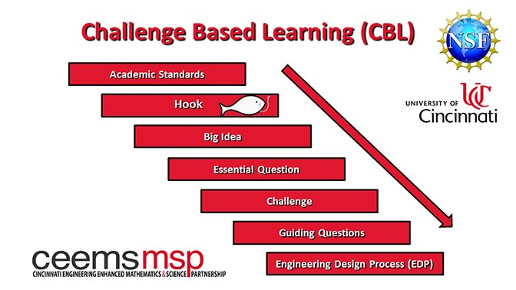
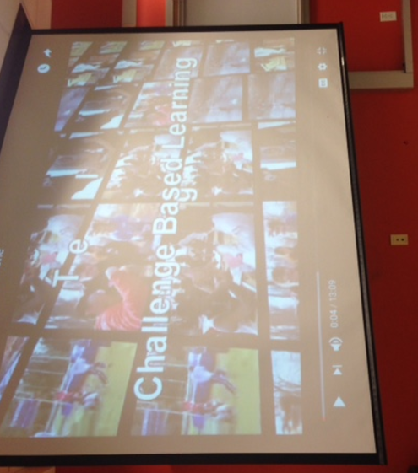
Ms. Terlau began her session by going through the Challenge Based Learning (CBL) process background. Ms. Terlau defined what CBL is by identifying each of its components. To further develop an understanding of the CBL components, she opened a discussion with RET participants about the what the components and foundations of CBL are. RET participants were then introduced to the CBL challenge they would be engaging in during the session. Before beginning the CBL challenge, Ms. Terlau explained how CBL connects with students by giving the students ownership of their learning and a purpose for learning.
Figure 2: Challenge Based Learning Flowchart
Figure 1: Challenge Based Learning Video

Next, RET participants were shown a flow chart and video (Figure 1) that explained the flow of CBL as it is delivered in the classroom. The video began by showing a flowchart (Figure 2) that showed the order of CBL as it is delivered in a classroom setting. The video then defined and showed an example of each CBL component as it is delivered in a classroom setting. The video showed real classroom footage and followed a teacher’s CBL lesson as the teacher explains the lesson to the students. The teacher began by explaining how academic standards are used to create a hook and big idea. The teacher then communicated how essential questions and guiding questions are developed by the students as the teacher aids in creating the challenge that utilizes the Engineering Design Process (EDP) for the CBL unit.
After the video, Ms. Terlau explained the difference between essential and guiding questions (Figure 3). Ms. Terlau defined essential questions as being broad in nature, avoiding questions that rely on “yes or no” answers. Ms. Terlau emphasized that it was important that students developed these essential questions from the overarching big idea. Ms. Terlau then explained guiding questions as those that are more specific and can be tested using the EDP process. Guiding questions should be developed by the students using the big idea and essential questions.
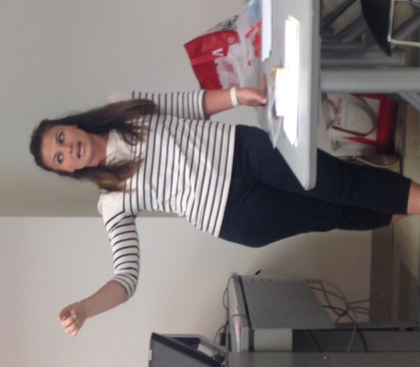
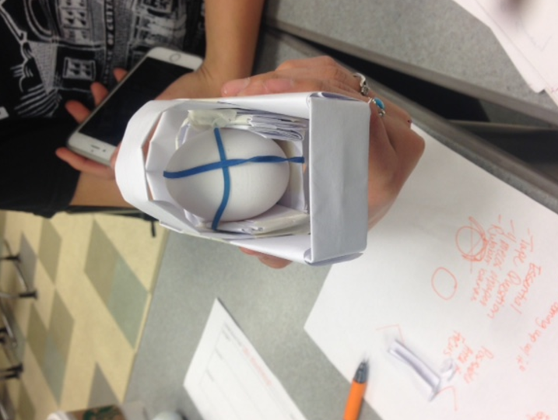
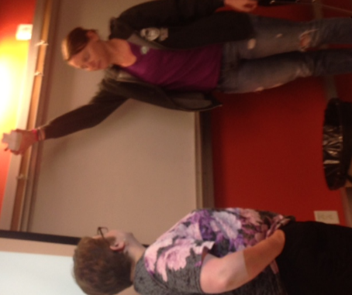

Figure 3: Explaining Essential Questions
Figure 5: Testing Solution
Figure 4: Design Example

Toward the second half of the session, RET participants were tasked with a CBL challenge. Participants had to build a helmet for a golf ball that would stay attached to the golf ball if dropped from a height of 6ft. Ms. Terlau prompted participants to think about some guiding questions that would be helpful to explore while brainstorming design ideas. Participants began to develop some guiding questions and communicated the questions with others in the room. After guiding questions were developed, participants began to sketch alternate solutions to the problem. A final solution was selected and tested with each team. At the end of the testing, Ms. Terlau communicated a change to the challenge. The helmets originally used for the golf ball were then going to be used for an egg. Ms. Terlau prompted the participants to form new guiding questions, brainstorm, and refine their old design to support an egg being dropped from a height of 6 ft. Participants then began to work on refining their old designs (Figure 4) and were allotted two extra sheets of paper and 6 inches of tape. After 10 minutes of refining the design, participants tested the new design in front of the room (Figure 5). The session concluded with questions about cost and time efficiency while doing CBL units in the classroom. Ms. Terlau explained the balance that is needed between time, cost, relevance, and standards connection when considering the CBL challenges.

